Supplement 2: Confusion matrix and ROC curve of the analysed models in the external evaluation.
Figure 1. Normalised confusion matrix showing patient-level classification results of the multimodal AlexNet model on the independent external validation cohort across the haematolymphoid, neuroectodermal and neural crest-derived, mesenchymal, and melanocytic tumour groups.
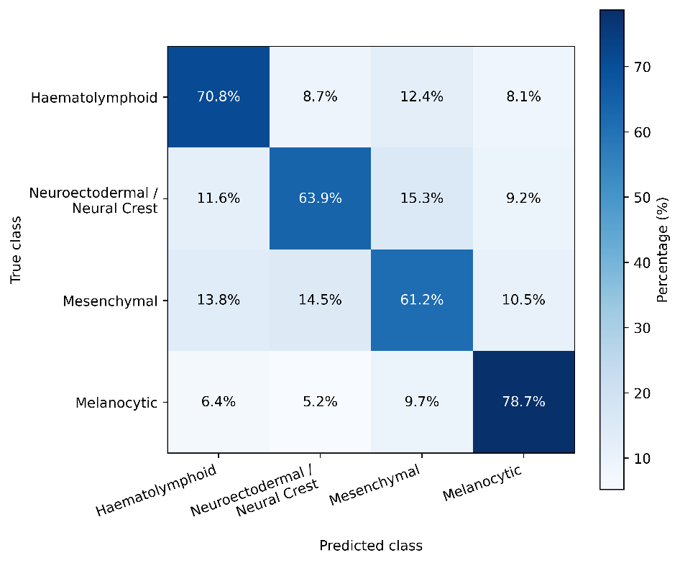
Figure 2. Receiver operating characteristic (ROC) curve showing the performance of the multimodal AlexNet model on the independent external validation cohort.
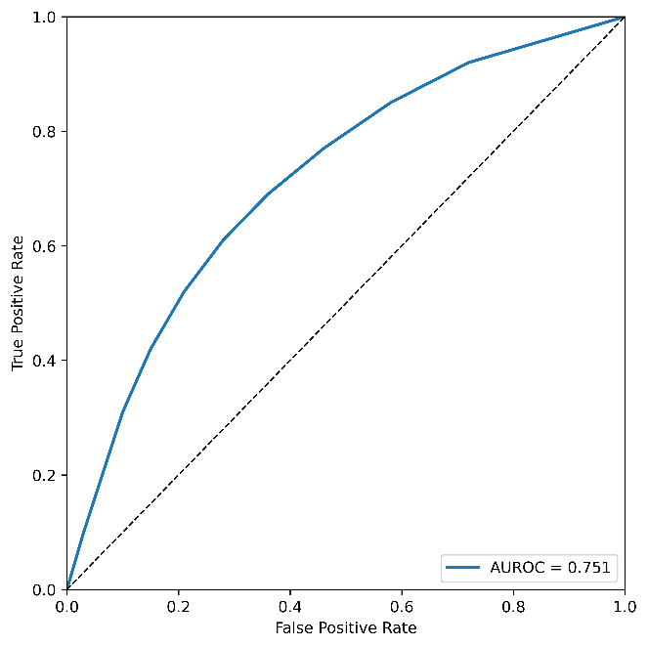
Figure 3. Normalised confusion matrix showing patient-level classification results of the multimodal MobileNet model on the independent external validation cohort across the haematolymphoid, neuroectodermal and neural crest-derived, mesenchymal, and melanocytic tumour groups.
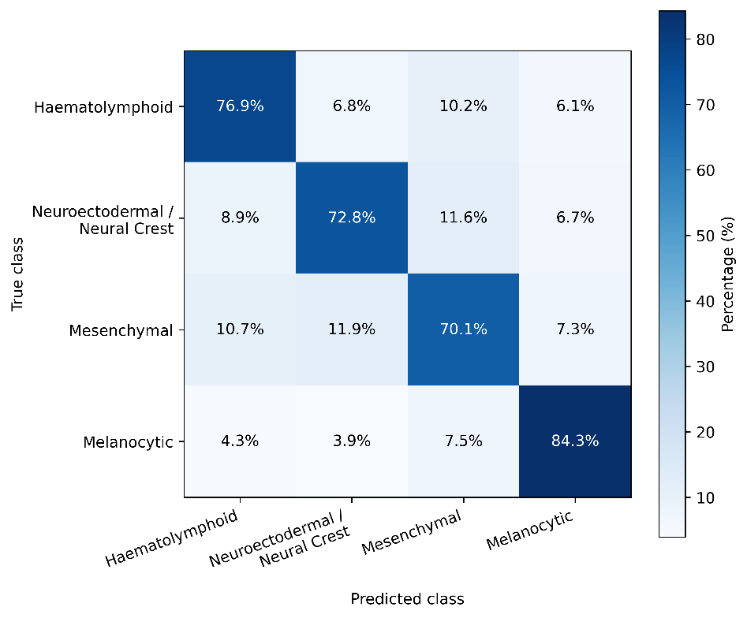
Figure 4. Receiver operating characteristic (ROC) curve showing the performance of the multimodal MobileNet model on the independent external validation cohort.
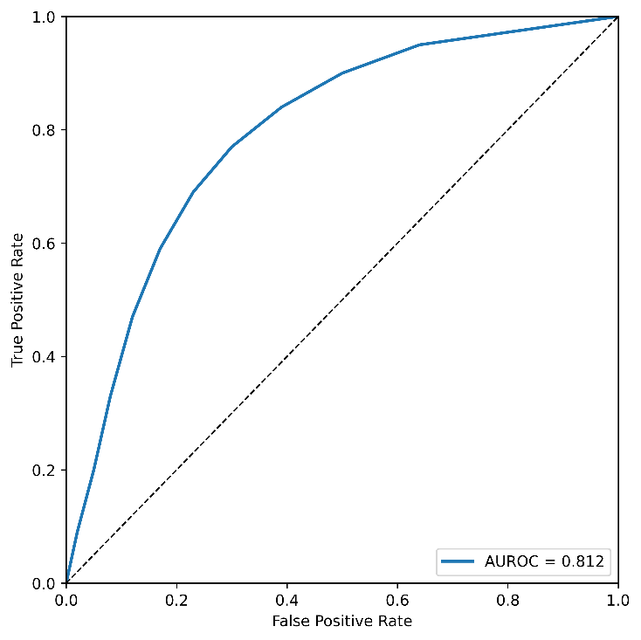
Figure 5. Normalised confusion matrix showing patient-level classification results of the multimodal InceptionV3 model on the independent external validation cohort across the haematolymphoid, neuroectodermal and neural crest-derived, mesenchymal, and melanocytic tumour groups.
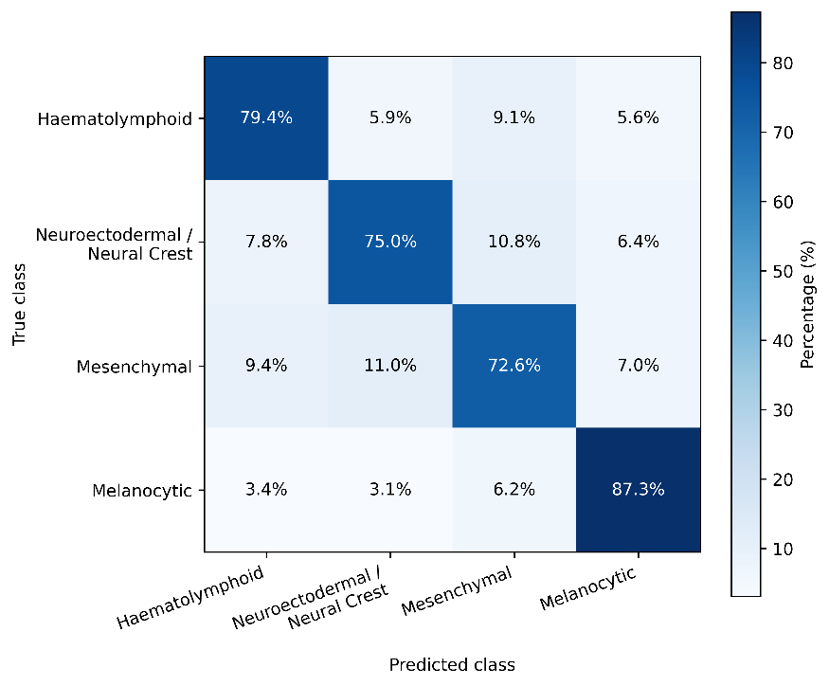
Figure 6. Receiver operating characteristic (ROC) curve showing the performance of the multimodal InceptionV3 model on the independent external validation cohort.
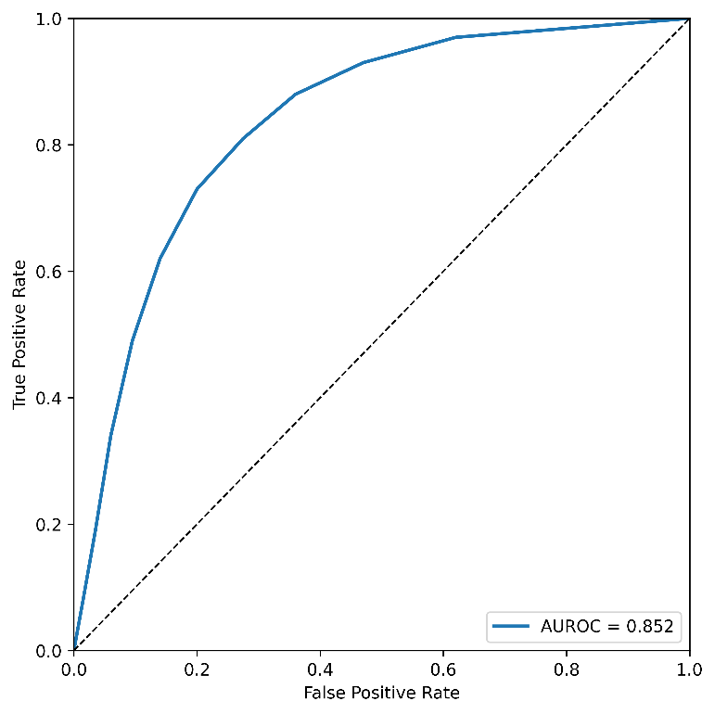
Figure 7. Normalised confusion matrix showing patient-level classification results of the multimodal DenseNet121 model on the independent external validation cohort across the haematolymphoid, neuroectodermal and neural crest-derived, mesenchymal, and melanocytic tumour groups.
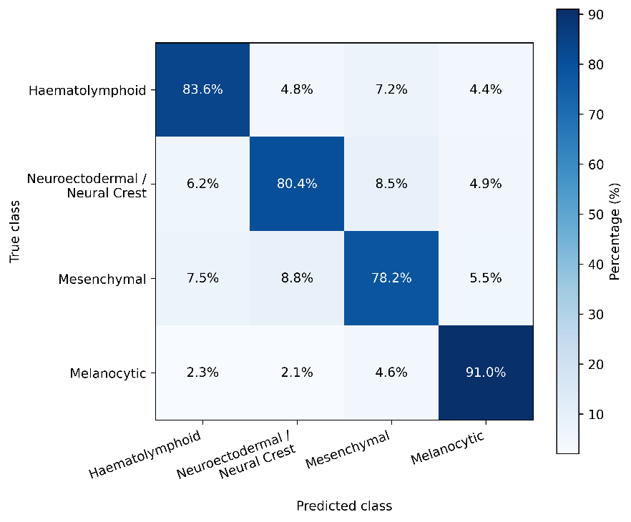
Figure 8. Receiver operating characteristic (ROC) curve showing the performance of the multimodal DenseNet121 model on the independent external validation cohort.
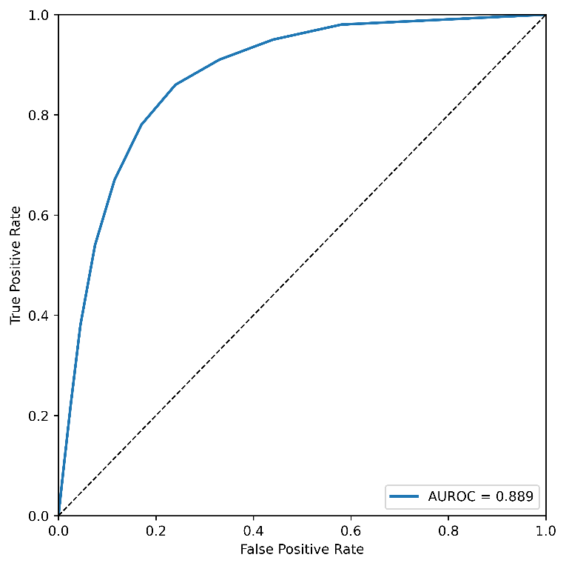
Figure 9. Normalised confusion matrix showing patient-level classification results of the multimodal Xception model on the independent external validation cohort across the haematolymphoid, neuroectodermal and neural crest-derived, mesenchymal, and melanocytic tumour groups.
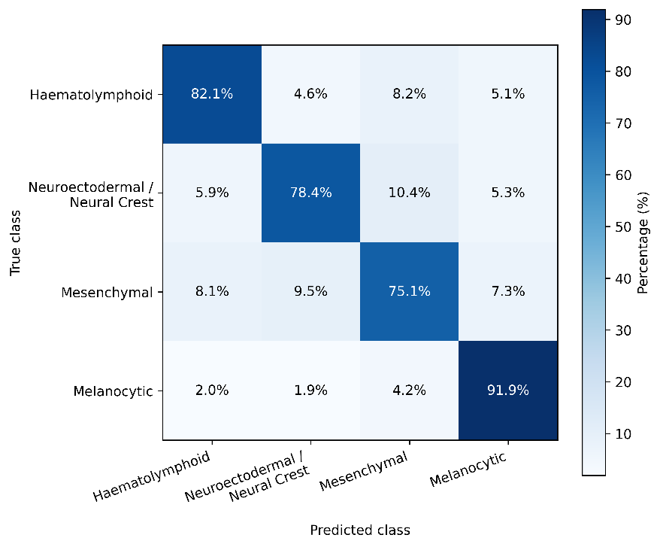
Figure 10. Receiver operating characteristic (ROC) curve showing the performance of the multimodal Xception model on the independent external validation cohort.
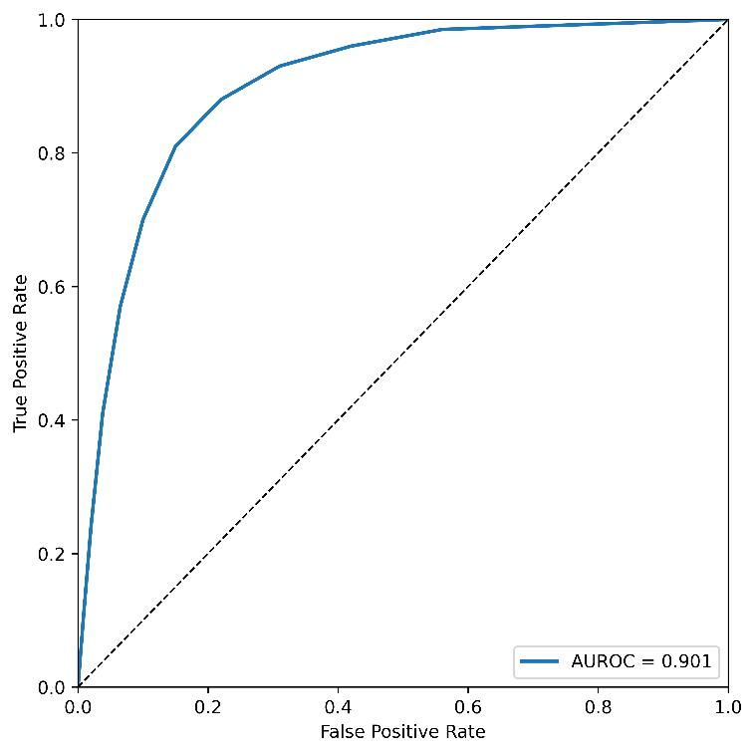
Figure 11. Normalised confusion matrix showing patient-level classification results of the multimodal ResNet50 model on the independent external validation cohort across the haematolymphoid, neuroectodermal and neural crest-derived, mesenchymal, and melanocytic tumour groups.
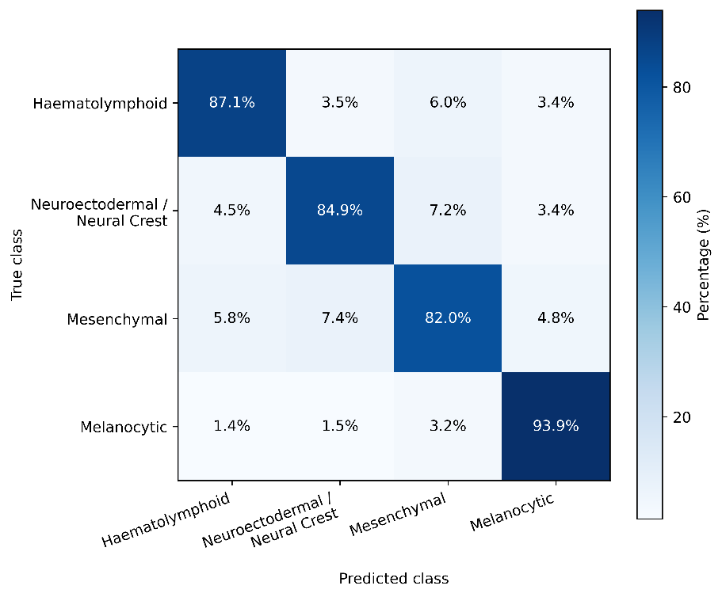
Figure 12. Receiver operating characteristic (ROC) curve showing the performance of the multimodal ResNet50 model on the independent external validation cohort.
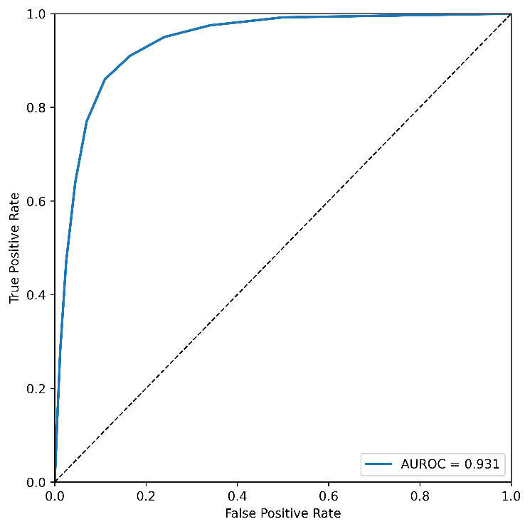
Figure 13. Normalised confusion matrix showing patient-level classification results of the multimodal CellViT++ model on the independent external validation cohort across the haematolymphoid, neuroectodermal and neural crest-derived, mesenchymal, and melanocytic tumour groups.
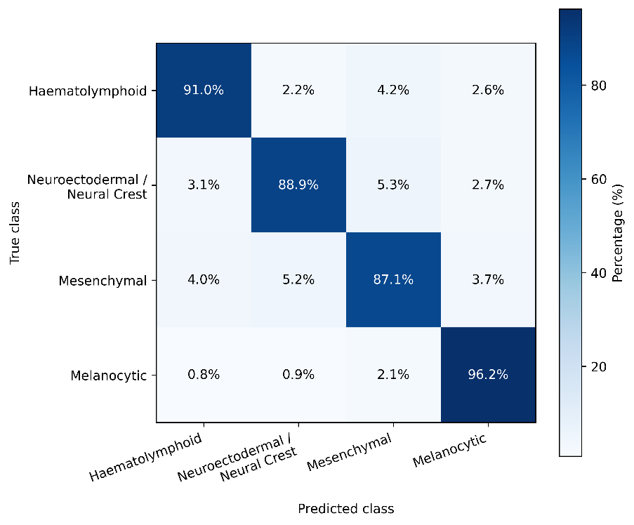
Figure 14. Receiver operating characteristic (ROC) curve showing the performance of the multimodal CellViT++ model on the independent external validation cohort.
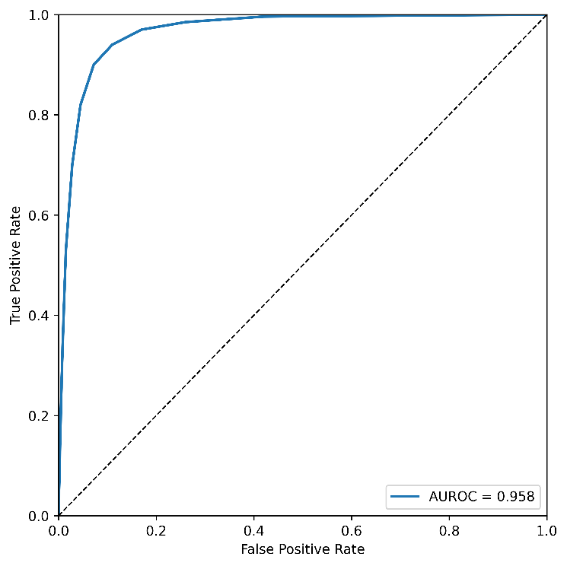
Figure 15. Normalised confusion matrix showing patient-level classification results of the UNI model on the independent external validation cohort across the haematolymphoid, neuroectodermal and neural crest-derived, mesenchymal, and melanocytic tumour groups.
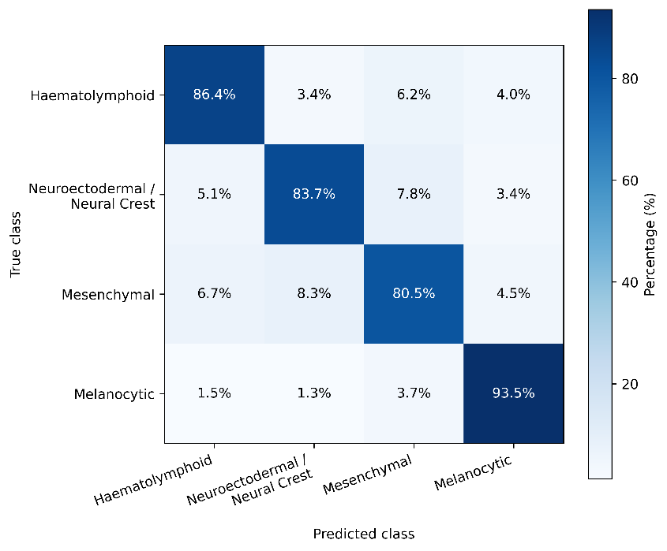
Figure 16. Receiver operating characteristic (ROC) curve showing the performance of the UNI model on the independent external validation cohort.
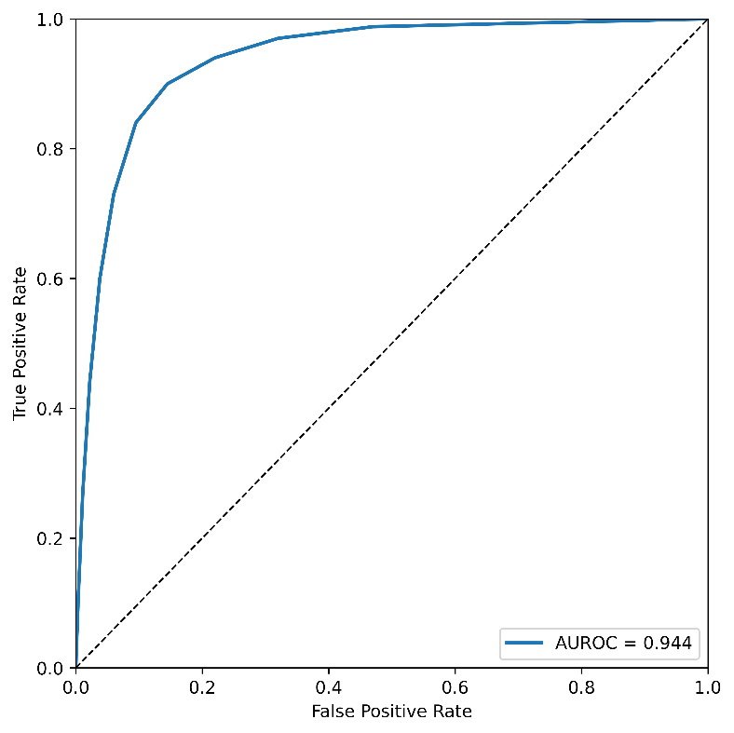
Figure 17. Normalised confusion matrix showing patient-level classification results of the Virchow model on the independent external validation cohort across the haematolymphoid, neuroectodermal and neural crest-derived, mesenchymal, and melanocytic tumour groups.
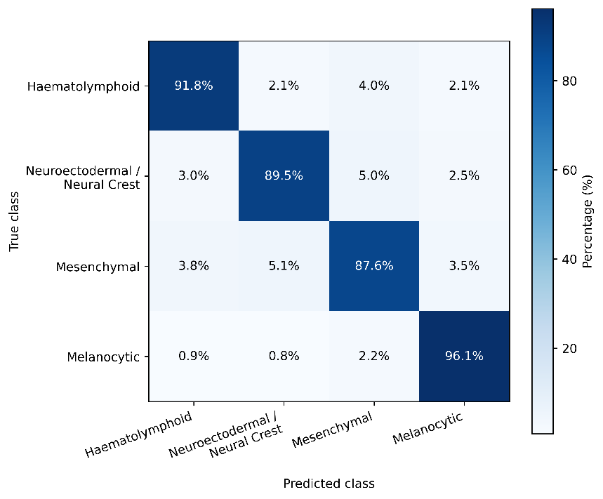
Figure 18. Receiver operating characteristic (ROC) curve showing the performance of the Virchow model on the independent external validation cohort.
